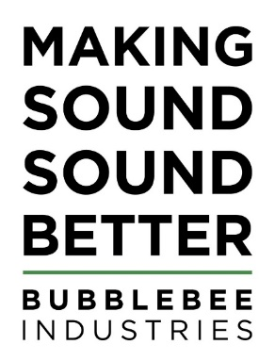
Bubblebee Audio Accessories Help Lauren Banjo Capture High Quality Sound
The US-based sound engineer who specialises in ENG explains how having the right tools for the job helps her achieve great results for her clients in all kinds of locations.

Copenhagen, Denmark. April 26th 2022: Location recording engineer Lauren Banjo has joined a growing band of professionals who are turning to Bubblebee Industries for their specialist sound accessories.

Based in New Jersey, USA, Lauren works mainly in New York capturing sound for film, television and corporate clients who want professionally produced content for internal communications and social media channels. In recent months her client list has included Adidas, Michael J. Fox, Samsung, World Umami Forum, Michael Bloomberg, New York Comic Con and Coach.

One Bubblebee product she uses on a regular basis is the Spacer Bubble, a multipiece adaptable windshield solution for shotgun microphones that is specifically designed to help boom operators and sound recordists cope with changeable conditions. The Spacer Bubble consists of a mesh base for use indoors, protecting against light winds caused by moving the boom, and a long-haired fur cover that slips over the base, providing excellent wind protection when moving outdoors. The whole setup can be easily adapted in a matter of seconds, so you always have the most transparent option for your surroundings.

“I’m also often involved in ‘Run & Gun’ productions, where environments can change quickly,” she explains. “In those situations, I am the person who follows the camera crew wherever they go, which could mean being inside one minute and outside the next. The great thing about the Spacer Bubble is that it is so lightweight and portable. If I’m outside in windy conditions, I can quickly slip the fur cover over my microphone and be confident that the sound will remain clear and intelligible. And when I don’t need it, the cover can be scrunched up so that it fits easily in a bag or in my pocket.”

Lauren’s Spacer Bubble recently came to the rescue when she was tasked with recording audio on a boat when the wind was gusting at 55 miles an hour.

“I used my Bubblebee Spacer and although you could hear that it was windy, there was none of the distortion one would normally expect,” she says. “If I had tried to record without the Spacer, I wouldn’t have been able to hear anything except wind.”

Having the right accessories does make a difference, Lauren adds, and investing in the best tool for the job is always money well spent. She is also a fan of Bubblebee concealer products for lavalier microphones because the rubber mounts have a very slim profile, and the metal guards stop friction noise from reaching the mic capsule.

“These days I use them as my default mounting option because they work well with the majority of wardrobe options,” she explains. “I also like Bubblebee’s lavalier Windbubble because these totally work when it comes to removing unwanted noise.”

-ends-

About Bubblebee Industries
Bubblebee Industries has been Making Sound Sound Better since 2011. Based in Denmark, Bubblebee designs high quality microphone wind protection and sound accessories for the production sound, field recording, live, sports and broadcast sound industries.
www.bubblebeeindustries.com

Company contact:
Caleb Hill
Email: caleb@bubblebeeindustries.com

Press contact
Sue Sillitoe
Tel: +44 (0) 1666 500142
Mobile: +44 (0) 7798 621891
Email: sue@whitenoisepr.co.uk

