NEWS RELEASE
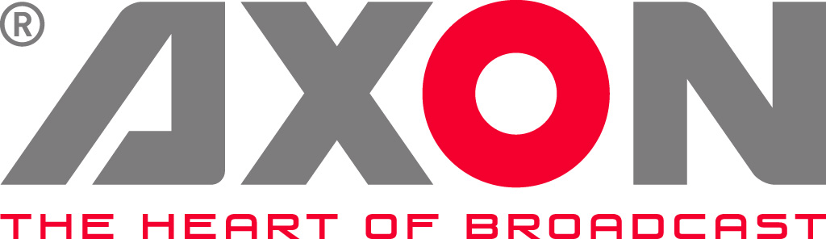

CTV Rolls Out Blueprint for Ultra-HD OB Fleet
Axon enables seamless 4K upgrade of three flagship OB units

Wokingham, UK: 28 February 2018: CTV Outside Broadcast, a subsidiary of Euro Media Group (EMG), recently completed the refurbishment and technical upgrade of three of its large flagship OB units to Ultra-HD, featuring Axon Synapse 4K signal processing, infrastructure, control and monitoring as standard.

After the successful debut of OB2 and OB11 in 2017, delivering landmark 4K events such as the Isle of Wight festival – a European-first in entertainment broadcasting – and international test cricket for Sky, the refit project is now complete on OB4 and the trio is busy on the road providing HD and Ultra-HD production capabilities for contracted and ad-hoc assignments.

CTV works closely with Axon and has relied on Synapse signal processing across its fleet for a number of years - a choice based on its proven reliability, scalability and design that is 4K-capable as a matter of course.

“The challenge in adopting Ultra-HD and HDR is how to effectively implement the new workflows without radically increasing costs – both in terms of technology and operator downtime,” says Richard Morton, CTV’s Head of Projects. “With Axon, we have a future-proof infrastructure that has enabled us to transition from HD to 4K without a snag.”

OB4 was the third vehicle to undergo a complete technology refit and the unit went into action to deliver Sky’s 4K coverage of the PDC World Darts Championship over the 2017 Christmas period. The triple-expanding-side OB features 24 Sony 4K cameras, a 160-input Sony MVS-8000X mixer plus six EVS server positions. It is supported by Axon 4K signal processing and 3G glue with Axon’s 4K production tools providing up and down converters that fit in the same form factor as the 3GB/s modules. Axon’s Cerebrum monitoring and control platform is at the heart of the operation, running three UHD galleries through an easy-to-use graphical interface and custom-built panels of 42 LED buttons.

CTV supports a wide variety of live sports and entertainment events and such productions demand efficient, flexible and adaptable workflows that can be easily operated by both staff and freelancers alike. Despite the complexities of upgrading to UHD, operators within each of the refurbished OBs continue to work in an environment and workflow with which they are very familiar.

“Axon continues to provide us with a proven unified workflow and control solution. We now have an efficient blueprint to roll-out across the fleet making the move to UHD, and eventually HDR, seamless and risk-free,” concludes Morton. “This strategy is keeping CTV at the leading edge of technology.”

In addition to regular live sports coverage, CTV has captured original entertainment shows in UHD HDR commissioned by Netflix.

-ends-

About Axon
Headquartered in The Netherlands, and with offices across the world, Axon develops, manufactures and markets high quality broadcast equipment for the conversion, processing, monitoring & control and compliance recording of audio and video signals. Products integrate advanced signal processing techniques, innovative engineering and modular flexibility and provide high quality, affordability and reliability within mission-critical broadcast applications. For more information, please visit
www.axon.tv.

For more information, please contact:
Axon Digital Design
Margot Timmermans / Geert-Jan Gussen | Email: press@axon.tv

