NEWS RELEASE
CABSAT 2017, 21-23 March
Hall 1 Stand D1-20
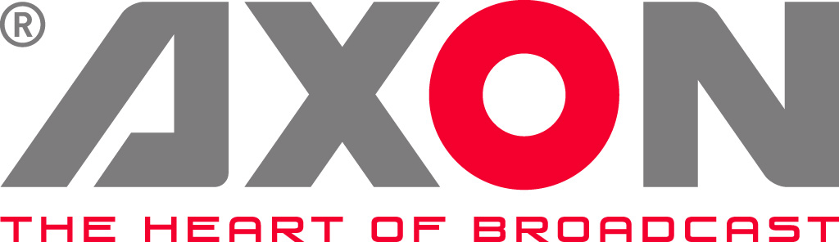

Axon celebrates 30th anniversary with IP products at CABSAT
New additions to Axon's portfolio are helping to ease broadcasters’ transition to IP & streamline production.

Gilze, The Netherlands. February 4th 2017: Broadcast infrastructure specialist Axon Digital Design, which celebrates its 30th anniversary this year, will be bringing to CABSAT a range of IP products and production tools that are designed to help broadcasters deal with the challenges of the move to IP. (Hall 1 Stand D1-20.)

As broadcasters and manufacturers look to the future, there is no doubt that IP will become the backbone of our industry because, with protocol enhancements, it will prove more convenient, more flexible and eventually cheaper than SDI. But in the meantime, until those benefits can be easily delivered, Axon’s strategy remains both customer-focused and pragmatic. Format-agnostic, the company is committed to delivering the products and hybrid/bridge solutions that are needed as broadcasters move from SDI to IP. At the same time, it is also working on the next generation of products where Ethernet is the default interface.

With this in mind, Axon is using CABSAT to unveil the NIO440, an a new 8-channel bi-directional Ethernet/SDI bridge to the Middle East market. Due to its highly flexible architecture, the NIO440 can help customers move to an IP based infrastructure with compatibility of all possible current and future standards. At present, the card is compatible with both AVB/TSN and s2022. Future standards like VSF-TR03/TR04 - and of course SMPTE-2059 - are also within its capability and compatibility will be achieved by future software upgrades.

The NIO440 provides the bridge from 3G/HD-SDI to uncompressed Ethernet video transport and de-centralized routing. It can be used as a point to point video/audio/data connection (using standard fiber-optic cables or SMPTE camera cables, avoiding CWDM infrastructures and cost) and it provides point to multi-point routing and distribution using IT switches.

Axon will also showcase its new SynView Multiviewer solution, which is capable of handling both 4K and any IP video formats. SynView is ideal for a wide range of applications and from small to extremely large monitoring walls, and is ready for the future because it can support whatever video transport mechanism the industry chooses to adopt.

Two basic models are available, each in two versions (SDI I/O or Ethernet I/O). These versions can be mixed and matched to build a hybrid multiviewer with up to hundreds of inputs and eight 1080p heads (on SDI) or two heads with UHD/4K resolution. Multiple connector panels will be available to allow for different I/O configurations. Compared to earlier systems, SynView’s feature-set has been significantly enhanced, with double the amount of inputs, eight times the amount of outputs (heads), UHD/4K/60Hz output resolution on display outputs and a 6-fold increase of processing power. The system can now scale, position, de-embed, overlay and process 8 video channels.

Axon’s CABSAT line-up will also include Cerebrum control and monitoring, which is fast becoming the solution of choice for mobile production, news and studio live production, master control and remote production. At the show, Axon will unveil its most open and flexible version of Cerebrum platform, which supports products from Everzt, AJA, AXIA, Allen & Heath, Panasonic, Ross, Yamaha, Rohde & Schwartz, Quintech and Black Magic. This makes it even simpler to monitor and control multiple devices on one easy-to-use interface.

Finally, Axon will highlight its ongoing work on 4K and IP by representing Utah Scientific Foundation routers that deliver SDI (including UHD) and S2022 content, in compliance with the AIMS roadmap for the transition to IP operations.

“Axon’s business in the Middle East continues to grow with the valued support of major regional broadcasters and media organisations including MBC, Sky News Arabia, Al Jazeera, BeIN, Qatar TV and OSN. During CABSAT we’ll be celebrating our 30th anniversary and it’s a great opportunity for us to thank our customers and partners as well as to showcase an exciting product line-up that delivers today and addresses the challenges ahead,” says Axon’s CEO Jan Eveleens.

For more information on Axon's product range and to meet the team, please visit CABSAT 2017 Hall 1 Stand D1-20 or visit www.axon.tv

-ends-

About Axon
Headquartered in The Netherlands, and with offices across the world, Axon develops, manufactures and markets high quality broadcast equipment for the conversion, processing and compliance recording of audio and video signals. Products integrate advanced signal processing techniques, innovative engineering and modular flexibility and provide high quality, affordability and reliability within mission-critical broadcast applications. For more information please visit www.axon.tv.
For more information, please contact:
Axon Digital Design
Margot Timmermans / Geert-Jan Gussen
Email: press@axon.tv

