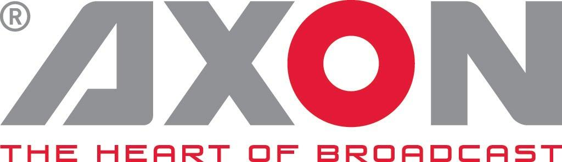
NEWS RELEASE
NAB, 07-12 April, 2018
South Hall SL12105

Axon and Arista to demonstrate live sports IP infrastructure at NAB2018

Showcase Mirrors Successful Recent Real-World Deployment

Gilze, The Netherlands. April 3rd 2018: Axon Digital Design and Arista Networks will use this NAB to demonstrate a proven live sports IP infrastructure. The showcase on Arista’s booth SL12105, in which a traditional SDI router has been replaced with an IP infrastructure, features Axon’s Synapse IP control solutions and Synview IP multiviewer, all managed by the Cerebrum control platform.

Visitors to NAB will experience a scaled down live demonstration used by a leading production company for a recent major international sports event. This original set-up consisted of multiple Arista 7050SX-64 switches in a leaf-spine configuration, combined with Axon’s Synapse IP bridges (NIO440) to convert to and from SDI, and controlled through Axon’s Cerebrum control & monitoring system. To feed IP signals directly to Axon’s Synview multiviewer, Synapse MNU100 modules were equipped with Synapse NIO440 converting SDI signals to IP for display on the multiview wall.

Demonstrating the agility and flexibility offered by IP, when combining Axon’s solutions with Arista’s software driven cloud networking platforms, the broadcast infrastructure on show can replace 6x72x72 routers (1080i – S2022-6). Flexibility, control and flow path awareness, while reducing the overall equipment footprint, enables new business models.

“We are delighted that our products performed as expected in this ground-breaking proof-of-concept and we’re proud to share this experience at NAB,” says Axon’s CEO Jan Eveleens. “As broadcasters look to move to a fully IP environment for live sports production, it’s great to be able to demonstrate our technology with confidence based on a successful real-world IP deployment.”

“This live proof-of-concept in a major international sporting event proves that by deploying IP broadcast networks with Arista Networks, media companies can take advantage of the same network management, performance, reliability and scaling efficiencies realized by cloud service providers.” said Ed Chapman, vice president of business development and alliances, Arista Networks.”

To see the live sports IP demo, visit Arista’s booth in the South Hall SL12105. For more information about Axon's product range, please visit Utah Scientific at NAB 2018 booth SL6324 or visit www.axon.tv

-ends-

About Axon
Headquartered in The Netherlands, and with offices across the world, Axon develops, manufactures and markets high quality broadcast equipment for the conversion, processing and compliance recording of audio and video signals. Products integrate advanced signal processing techniques, innovative engineering and modular flexibility and provide high quality, affordability and reliability within mission-critical broadcast applications. For more information please visit www.axon.tv.
For more information, please contact:
Axon Digital Design
Margot Timmermans / Geert-Jan Gussen
Email: press@axon.tv

