NEWS RELEASE
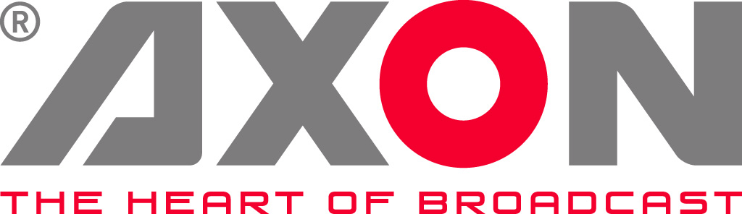

Axon's Cerebrum Takes Centre Stage at Metro TV

The Indonesian broadcaster has put this advanced monitoring and control software at the heart of its 24 hour news operation.

Gilze, The Netherlands. November 16th, 2015: Metro TV, Indonesia's first 24 hour news channel, has installed Axon Digital Design's Cerebrum monitoring and control software as part of a major upgrade of its High Definition news studio.

Based in West Jakarta, the station chose Cerebrum because it provides a fully automated and seamless workflow and delivers significant cost savings by reducing downtime.

Jaja Karjaya, Engineering Manager at Metro TV, says: "In conjunction with our systems integrator Magna Systems Engineering, we evaluated several Network Monitoring System (NMS) solutions from different vendors to ascertain which one was right for us. We chose Cerebrum because it delivered all our key requirements. These included stability, instantaneous response, ease of use, flexibility and the ability to monitor and control our existing equipment. Cerebrum also gives us the flexibility to increase the amount of third party equipment that we might want to monitor over time."

Designed as an advanced and customizable monitoring and control system, Cerebrum links broadcast equipment from all major manufacturers using either SNMP (Simple Network Management Protocol) or third party protocols. The system supports a wide range of devices including routers, production switchers, servers, audio desks, camera control units, receiver decoders, multiviewers and waveform monitors, and its advanced functionality and broad range of features simplifies multi device control onto one easy-to-use interface.

"As a 24 hour facility, we cannot afford to have any disruption to our On Air program," Karjaya adds. "Installing Cerebrum has helped our engineering teams to narrow down any problems within our workflow and this has significantly reduced the amount of time it takes to find faults. The engineers can also remotely access the system to determine which piece of equipment is causing problems within the workflow."

Metro TV currently operates one channel, but thanks to the flexibility of its Axon SynMC Master Control system which has been installed alongside Cerebrum, the station has plenty of scope for future expansion.

"Our SynMC Master Control system is capable of handling 16 channels, and with this backbone is in place, all we would need to do to increase our channel count is add a few more cards to our existing system," says Karjaya "As far as Cerebrum is concerned, its capacity to offer a future proof solution lies in its ability to cope with any equipment enhancements or improvements we might make. We are free to introduce new pieces of equipment or undertake software upgrades because Cerebrum can easily cope with these types of change."
Cerebrum is fast becoming the control solution of choice for mobile production, news and studio live production, master control and remote production. Recent installations including CTV Outside Broadcast, eTV in South Africa and News UK, which has included Cerebrum in its state-of-the-art broadcast facilities in London.

-ends-

About Axon
Headquartered in The Netherlands, and with offices across the world, Axon develops, manufactures and markets high quality broadcast equipment for the conversion, processing and compliance recording of audio and video signals. Products integrate advanced signal processing techniques, innovative engineering and modular flexibility and provide high quality, affordability and reliability within mission-critical broadcast applications. For more information please visit www.axon.tv.
For more information, please contact:
Axon Digital Design
Margot Timmermans / Geert-Jan Gussen
Email: press@axon.tv

