

PMC
Contact: Keith Tonge
43-45 Crawley Green Road
Luton
LU20AA
UK
Tel: +44 (0) 870 4441044
Fax: +44 (0) 870 4441045
Email: keith@promonitor.co.uk
www.pmcloudspeaker.com

Prism Media Products Inc
Contact: Maurice Patist, VP Sales
17952 Sky Park Circle
Building 45, Suite D
Irvine, CA 92614
USA
Tel: +1 949 861 3350
Fax: +1 949 861 3352
Email : sales@prismsound.com
http://pmpi.prismsound.com

PRESS RELEASE
March 5th 2012

PMC At The 84th ©Academy Awards®
MB2 XBD & AML2 Speakers Provide Critical Listening Facilities At The ©Oscars®

California, USA: PMC speakers, distributed in the USA by Prism Media Products Inc, provided critical reference monitoring facilities for broadcast and film mixing engineer Tommy Vicari at two key stages during the 84th ©Academy Awards® — the ©Oscars® to most of us — at the end of February.

Vicari, who has worked on a huge range of Hollywood movies from The Help to Finding Nemo, used a pair of MB2 XBD speakers supplied by Prism Media Products Inc during rehearsals and pre-recording sessions at Capitol Studios, Hollywood, in the days running up to the awards ceremony. On the night itself, the broadcast truck for the event used PMC's compact full-range AML2s to monitor all of the live and pre-recorded musical cues and themes created by this year’s Musical Director, composer Hans Zimmer.

The broadcast mix from the truck was also overseen by Tommy Vicari, for whom it was the 13th year mixing the music for the Oscars, but his first using PMCs.

"I've been a PMC user for 11 years," he comments, "and can't say enough about how I love them. There are no surprises — whatever I mix on the PMCs comes out ready for the soundstage. This year, Hans Zimmer was trying something novel and ambitious with the music, so I wanted to reproduce my movie mixing rig for the pre-recording sessions to help make him feel more comfortable. And for the last three years, my movie mixing setup has been an array of PMC MB2 XBDs with Bryston amps. Maurice Patist, of Prism Media Products Inc, brought down a duplicate set to Capitol and tuned them personally, with really great results.

"The musical cues for the Oscars are always pre-recorded as a safety measure before the show; they need recordings as backup in case anything should go wrong technically on the night. For the past few years, the pre-recording sessions have also served as a practice session for the musicians to get to know the music. This year, there was all kinds: rock, orchestral, world, hip-hop… we went through over a hundred cues in two days. The speakers sounded great, and as I'd hoped, Hans really loved them."

For the live broadcast, Vicari felt that the MB2 XBDs were too large for Remote Recording Services' broadcast truck. However, Maurice Patist had a further card up his sleeve — the smaller AML2s, which are designed to provide the same dispersion, balance and resolution in a more compact package. "I'd not used these before, but Maurice suggested I try them, and I was really impressed, as was everyone else in the truck. Despite their size, they were really powerful in the bass range — I didn't need a subwoofer. They also stayed very clean-sounding, with a crisp and clear top end."

Vicari looks forward to auditioning the AML2s in his own studio. For now, he is delighted with how the live broadcast went. "We always try to give the audience at the Oscars an elegant experience. This year, what can I say? I worked with some very talented people… and the speakers sounded great!"

-ends-

Pictures and captions
The following images are available to download from their accompanying links:
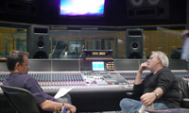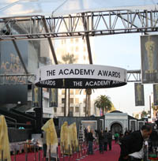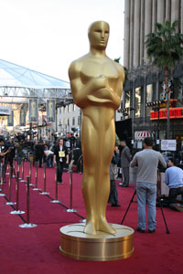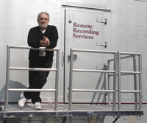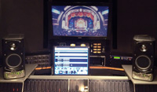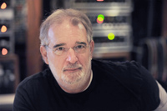

Pic at http://tinyurl.com/7hm9c9m
PMC’s MB2 XBDs at Capitol during the pre-recording and rehearsal sessions for the ©Oscars®, with Capitol Studio A House Engineer Steve Genewick left and Tommy Vicari right.

Pics at http://tinyurl.com/7kunh5s and http://tinyurl.com/79uw5pm
The red carpet on the night of the awards (©Oscar® statuette ©A.M.P.A.S.®).

Pic at http://tinyurl.com/7vutfxz
Tommy Vicari outside Remote Recording Services’ broadcast truck during a break in transmission.

Pic at http://tinyurl.com/7x4qz83
PMC’s AML2 monitors in the truck during the broadcast

Pic at http://tinyurl.com/88wxmfd
Tommy Vicari at the end of the night.

NOTES
‘Oscars’ and ‘Academy Awards’ are a trademark of the Academy of Motion Picture Arts & Sciences.

MB2 XBD
The MB2 XBD is a development of the successful MB2S with increased dynamics and LF performance. The addition of the XBD cabinet containing a second precision 12-inch Radial™ driver increases the LF headroom by 3dB below 380Hz, and allows a larger room to be driven to greater effect. In a surround configuration, the added headroom of the XBD allows the ‘point one’ surround effects channel to be handled with ease, avoiding the need to install further sub units. The 32-element, 4th-order passive crossovers are housed in external enclosures which can be mounted to the rear of the XBD cabinets for improved fidelity. This is an ideal monitor for music recording, mastering and post-production in either stereo or surround configurations. For more information, see the dedicated MB2S product page on-line at:
www.pmc-speakers.com/product.php?mode=view&pid=23.

AML2
The new AML2 further extends the design of the internationally acclaimed AML1, with newly introduced micro-engineered EQ tilt circuitry, enhanced power supply layouts, a revised cabinet structure with additional damping, and subtly revised cosmetics. This uncompromising design offers performance unmatched by any other speaker of a similar size and volume; for example, the unique driver arrangement, with a crossover point of only 1.4kHz, enables the AML to deliver an amazingly accurate portrayal of music or speech. For more information, see the dedicated AML2 product page on-line at:
www.pmc-speakers.com/product.php?mode=view&pid=41.

About PMC
PMC is a UK based, world-leading manufacturer of professional monitor and audiophile speaker systems.

PMC designs feature its uniquely engineered Advanced Transmission Line (ATL™) technology, which provides a near-identical, high-resolution, wide-bandwidth signal response across the complete product range. Proprietary drive units, electronics and cabinet engineering provide unrivalled tonal accuracy, clarity and dynamic range throughout a range of designs, extending from the world’s smallest ATL™ design, the DB1+, to large-scale active control room monitoring systems such as the flagship BB5-XBD-A.

PMC monitor systems are in service with most of the world’s premier music and film sound recording studios, broadcast companies, post-production and audio mastering facilities. For further information and an extensive list of clients, visit www.pmc-speakers.com.

About Prism Media Products Inc
Prism Media Products Inc. is the US distributor for Prism Sound, SADiE, Maselec, PMC and Imerge.
For more information: http://pmpi.prismsound.com

Prism Media Products Inc
HQ Contact: Janice Norton
21 Pine Street
Rockaway
NJ 07866
USA
Tel : +1 (973) 983 9577
Fax : +1 (973) 983 9588
Email : sales@prismsound.com
http://pmpi.prismsound.com

West coast contact: Maurice Patist
+1 (949) 861 3350

