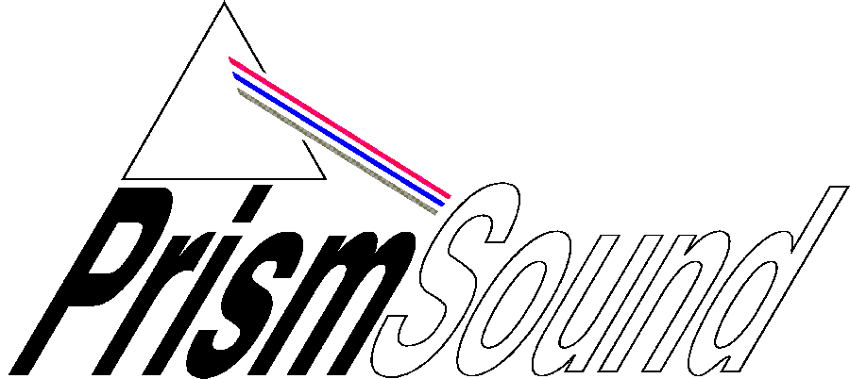

White Noise
Public Relations Ltd
Tel/Fax:
+44 (0) 1666 500142
Email: sue@whitenoisepr.co.uk

Prism Sound/SADiE
The Old School,
Stretham, Ely,
Cambridge CB6 3LD
T: +44 (0) 1353 648 888
F: +44 (0) 1353 648 867
Email: sales@prismsound.com
Web: www.sadie.com
www.prismsound.com

PRESS RELEASE
December 2008

Prism Sound and SADiE help Producer Tony Platt Complete a Vital Mix

Cambridge, UK: Prism Sound’s Orpheus multichannel Firewire audio interface is being hailed as a ‘saviour’ by producer Tony Platt after he employed the device to rescue a vital mix session for SellaBand artist Daniel Ward-Murphy.

Platt, who is a director of the Music Producers Guild, was working on the mix in his project studio, The Shop, located within the Strongroom complex in London. At a critical point in the session the A/D converter he had planned to use suddenly became unavailable – and to add to his problems his own audio interface box began misbehaving.

A quick call to Prism Sound brought an instant solution when the company agreed to loan him an Orpheus unit so that he could complete the mix.

“Prism Sound was fantastic,” Platt says. “Not only did they agree to lend me an Orpheus but Chris Allen delivered it in person to make sure everything went smoothly. In fact he needn’t have worried because this unit really defines ‘plug and play’. The software loaded very easily and the graphical interface is perfect for the usual professional male technique of only reading the manual when you absolutely need to – it is logical and easy to navigate.”

Platt mixed from Pro Tools via his Mackie console into the Orpheus and then back into Pro Tools via AES. Safety monitoring was achieved via an AES loop back to the Orpheus patched into the 2 track return. The session was at 96Khz/24bit with the clocking centrally achieved with an A&D ProBox 12.

“There were a couple of initial clocking issues but when we applied the AES DI to clock the Orpheus everything stabilised,” he explains. “From that point on the rest of the session went very smoothly and the unit behaved impeccably.”

Platt particularly liked the fact that Orpheus gave him the ability to A/B the audio and demonstrate to his client the value of high quality conversion.

“Much to my delight I detected slight but definite warmth in the low end after going through the Orpheus,” he says. “I know Prism Sound prides itself on total transparency, but I actually prefer equipment to have character and personality and I firmly believe this very slight enhancement is highly beneficial. Most importantly, though, the clarity was maintained with all the transient detail – certainly the artist was impressed!”

Prism Sound’s involvement in the project continued beyond the mix and into mastering when Tony Platt used a Dream DA-2 conversion system to provide a high-quality audio stream. He also used digital audio workstations from SADiE, now part of the Prism Sound group, which are the de facto standard at Fluid Mastering in London, where the mastering session took place.

Daniel Ward-Murphy’s melodic and powerful debut album Until The Morning Light features a repertoire that he has spent the last couple of years honing and perfecting in venues around London, where he regularly performs. Initial reviews have been very favourable with reviewers picking up on the exceptional production values that bring out the best out of Daniel and his band.

The album is now available on the SellaBand label (www.sellaband.com) – itself an unusual venture as it challenges the traditional music industry by encouraging artists and music lovers to go into business together. Anyone can invest in a SellaBand artist or band and once they have achieved the required amount of investment, investors receive a limited edition copy of their album. On top of that, the artists and their fans share equally in the revenues of the album. To date 29 artists from 12 different countries have raised the full $50,000 and over $2,200,000 has been invested in unsigned acts.

One key factor in SellaBand’s success is its strong network of producers. Its artist have the opportunity to work with world class producers, such as Greg Haver (Super Furry Animal, The Manic Street Preachers), Tony Platt (AC/DC, Bob Marley) and Steve Bush (Stereophonics).
“SellaBand is a fantastic concept and one that is already helping to unlock talent that might not otherwise have been heard,” Tony Platt explains. “As a producer I’m delighted to be part of it because I believe all artists, whether established or just starting out in their careers, deserve access to the best technology and the highest production values possible. Prism Sound’s Orpheus unit fits this philosophy perfectly because it offers such exceptional sound quality. As soon as I can raise the cash it is going straight on my shopping list!”

-ends-

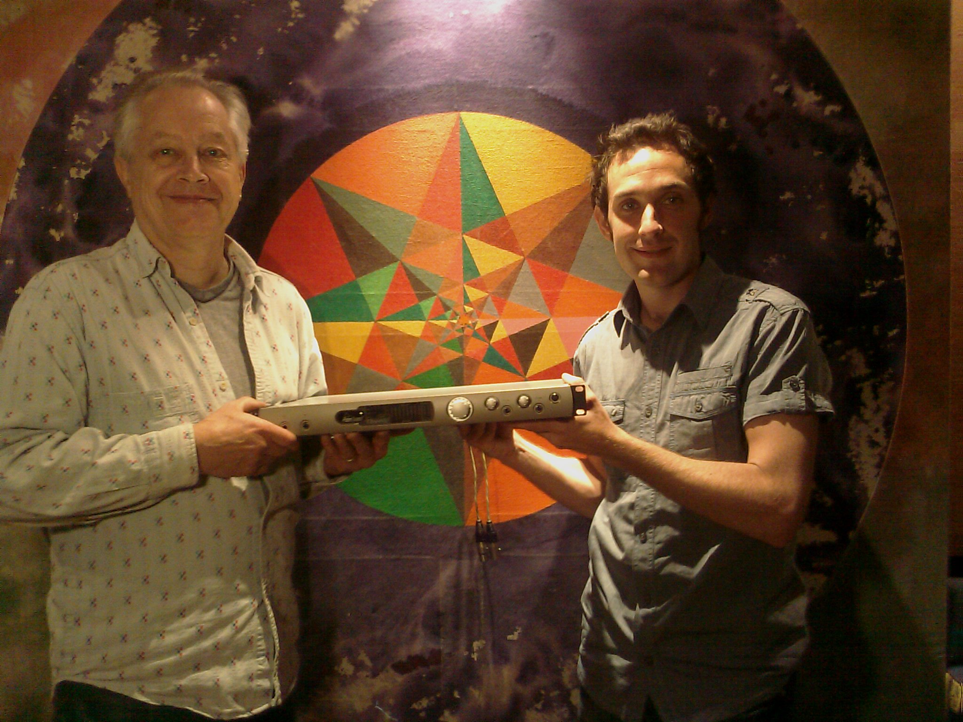
Picture caption: Tony Platt with Daniel Ward-Murphy and Orpheus. Please contact sue@whitenoisepr.co.uk for a high res version of this image.

About Orpheus:
Launched in 2007, Orpheus is a 1U, 19-inch rackmount 192kHz-capable computer-based Firewire interface that offers eight simultaneous balanced analogue inputs, four line-level jack inputs and four auto-sensing mic/line Neutrik combi jacks accepting either jack or XLR connectors.

The high-quality mic preamps allow the signal at the mic-level inputs to be boosted by up to 60dB (in 1dB increments), and each analogue input has its own adjustable patented Prism Sound Overkiller built in, to prevent signal overloads before the A-D conversion stage. There are also a switchable SPDIF/AES-EBU stereo digital input and an eight-channel ADAT optical input, allowing the Orpheus to handle a maximum of 18 simultaneous inputs to a computer-based recording system hooked up to the unit's main Firewire connector.

A built-in mixer is included, driving eight analogue outputs, allowing users to monitor input signals with zero latency, insert analogue summing mixers, or control multiple stereo or multi-channel monitoring systems directly from Orpheus. Prism Sound's respected high-quality, low-jitter digital clock source is also built in, along with synchronous sample-rate conversion and SNS noise-shaping, permitting accurate real-time reclocking or sample-rate conversion, or high-quality dithering of 24-bit material down to 16-bit for CD mastering.

Orpheus is fully software-controllable via a cross-platform control application (available for PCs running Windows XP, Vista or Macs running OS X). This makes it ideally suited to computer-based musicians who want to work with modern computer-based DAWs but wish to maintain the quality of signals from analogue recording sources or processors in the digital production environment.

About SADiE:

SADiE is the premium craft editing and mastering solution for high-quality audio and is standard equipment in many of the world’s leading Mastering Studios including Metropolis Mastering and Abbey Road, to name but two. SADiE is used by many remote (or location) recording practitioners in applications ranging from music ensembles to reality TV shows. SADiE also provides solutions to the broadcast market including the audio craft editing solution for BBC Radio and hardware-based remote-controlled multitrack audio recorders for Outside Broadcast (OB) applications. SADiE has several thousand users distributed across the various BBC locations in the UK and a strong user-base worldwide.

About Prism Sound
Founded in 1987, Prism Sound manufacture high-quality professional digital audio equipment for the International broadcast, film, music production, manufacturing and telecommunications sectors. The range now includes SADiE digital audio workstations and location recorders. Prism Sound also manufactures audio test and measurement products such as the DSA-1 and the dScope Series III audio analyzer.
For more information please visit www.sadie.com or www.prismsound.com

Note To Editors
The name Prism is widely used in different markets and by many different companies worldwide. The Cambridge-based UK manufacturer of audio interfaces, test and measurement equipment and logging systems, to whom this press release refers, seeks to avoid commercial confusion with these other markets and companies by always using its full name, Prism Sound, in its commercial communications. To avoid further action by these companies, Prism Sound respectfully ask that this convention be followed in print and on-line media which refer to their company and products. Thank you.

