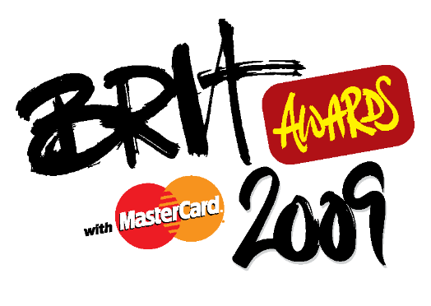

PRESS RELEASE
December 2008

Tickets Now On Sale For The Inaugural Music Producers Guild Awards

London, UK: Tickets are now on sale for the inaugural Music Producers Guild Awards, which take place at London’s Cafe de Paris on February 12th 2009.

This dazzling and opulent venue will provide the backdrop to an Awards ceremony that is set to become an annual highlight on the music industry’s calendar.

As a result of a unique collaboration with the UK’s recorded music industry trade association, The BPI, the winner of the Music Producers Guild’s Producer of the Year Award will also receive the BRIT Award for Best Producer. Both awards will be presented at the Music Producers Guild’s Awards ceremony, which will take place one week before The BRIT Awards 2009, to be held on Wednesday February 18th at London’s Earls Court Arena and broadcast Live on ITV1.

The Music Producers Guild Awards has 13 categories in total covering engineers, mixers, re-mixers and programmers, plus awards for Best Recording Facility, Best Mastering Engineer, Best Newcomer and Unsung Hero (who could be anyone from a runner to a studio receptionist).

This is a fantastic opportunity to recognise the enormous contribution recording professionals make to the success of the UK’s music industry.

Tickets cost £100 plus VAT for MPG members and £140 plus VAT for non-MPG members. An early bird discount is available, reducing the cost to £85 and £125 plus VAT respectively, so book now to avoid disappointment. To reserve your ticket, please telephone 0207 287 4655. Email sue@bubblesqueak.co.uk

-ends-

The Music Producers Guild would like to thank our Awards sponsors:

Prism Sound – Headline Sponsor
The Brits
Digidesign
Shure
Deep Recording Studios
TL Audio
RAK Studios

Event Organiser:
Sadie Groom
Bubble & Squeak
Tel: 0207 287 4262
Email: sadie@bubblesqueak.co.uk

Press Contacts:
MPG - White Noise Public Relations
Sue Sillitoe
Tel: 07798 621 891
Email: sue@whitenoisepr.co.uk

Brit Awards – LD Communications
Holly Ferguson
Tel: 07894 443 597
Email: holly@ldcommunications.co.uk

